ASSIGNMENT SOLUTIONS

# 8TH FEBRUARY

Q1 : What is Abstraction in OOps? Explain with an example.

ANS : Abstraction means hiding the complicated parts of something and showing only the important parts. In object-oriented programming, abstraction is achieved by creating classes and interfaces.

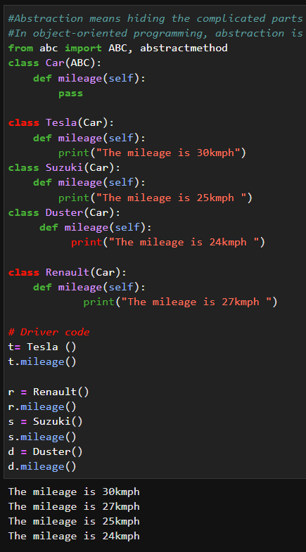

Q2 : Differentiate between Abstraction and Encapsulation. Explain with an example.

ANS : Abstraction is the process of representing complex real-world problems in a simplified manner. It focuses on the essential features of an object, ignoring the non-essential details. Abstraction provides a way to manage complexity and make it easier to understand and modify the system.

Encapsulation, on the other hand, is a technique used to hide the internal details of an object from the outside world. It is a way to protect the internal state of an object from being modified or accessed directly by other objects. Encapsulation provides data security and improves the maintainability of the code.

Example of encapsulation

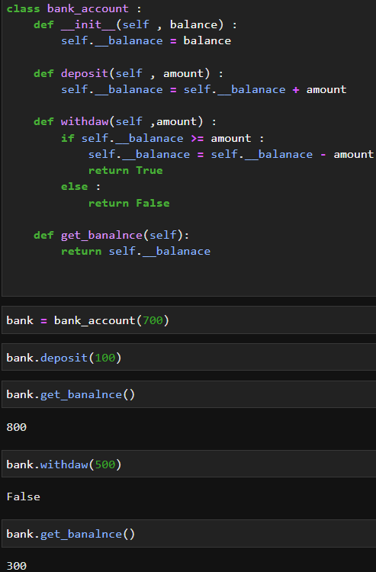

Q3: What is abc module in python? Why is it used?

ANS: The "abc" module in Python stands for "Abstract Base Classes". It provides a way to define abstract classes in Python

The "abc" module is used to define abstract classes and abstract methods in Python. The module provides a base class called "ABC" that can be used to define abstract classes.

Q4. How can we achieve data abstraction?

ANS: Data abstraction is the process of representing complex data in a simplified manner so that only the essential details are shown and the unnecessary details are hidden. It is achieved in Object-Oriented Programming (OOP) by using the following techniques:

1: Encapsulation

2: Abstract classes

Q5 : Can we create an instance of an abstract class? Explain your answer.

ANS: 